**Week 2 – Homework Exercise 1**

1. **Viewing a Report in the Report Viewer**
   1. Open the browser and sign into SAS Viya for Learners (SAS Drive) using your student credentials.
   2. Open and interact with the **Product Report** in the Report Viewer. You can access the report by navigating through **SAS Content > Courses > YVA185 > Basics**
   3. View the Product Analysis page.
      1. View information about the page and answer the following question:

What interactive links are available for the Product Analysis page that provide detailed information?

**Answer**: Profit and Quantity by Product Category, Top 10 Cities By Orders, Profit by Product Group, Graph of Profit, Number of Orders and Order Date.

* + 1. View report objects and use actions between the graphs to answer the following questions:

Which product category has the fewest number of orders? The lowest total profit?

**Answer**: The fewest number of order is “Indoor Sports” with 11,775 total profit is “Team Sports” with $33,185.52

Which product groups are included in the Indoor Sports category?

**Answer**: Fitness, Gymnastic Clothing, and Top Trim are in “Indoor Sports”Category

How many products are in the Fitness product group?

**Answer**: 45 producsts in Fitness Product Group

Do any fitness products generate a loss?

**Answer**: Yes, Letour 757 Home Exercises a TrimSport B.V had a loss with 1,331.50, Letour Mag Plus Bike-Buy Now paper at TrimSports B.V had a loss with 31,748.60, Letour Spinner Bike at TrimSports B.V had a loss with 1,745.10, and Weights 15kg dumbbell at TrimSports B.V had a loss with 541.26.

What are the top two cities by orders for fitness products? By profit?

**Answer**: London with $523.38 and Houston with 278.20

* + 1. Save an image of the dual axis time series plot filtered by *Indoor Sports* and *Fitness*.

**Answer**: 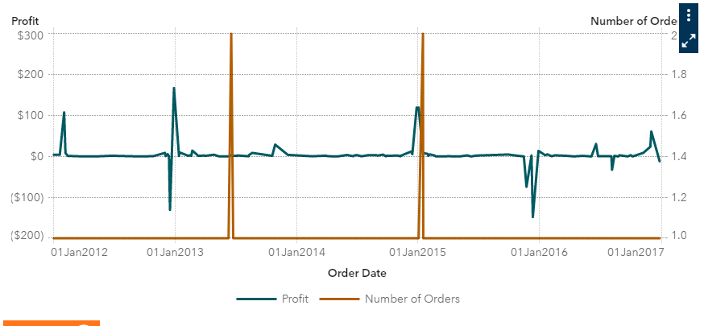

* 1. Close the report and sign out.

End of Practice

Week 2 - Homework Exercise 2

*You have been hired as an analyst and report designer for the Human Resources Division of Orion Star.*

*For your first assignment, the Human Resources team has asked for an analysis of salaries to determine which employees could be eligible for promotion based on job title, tenure, hire month, and sales accomplishments. You need to access and investigate the data to determine which modifications need to be made to satisfy their requirements.*

1. **Accessing and Investigating Data**
   1. Open the browser and sign in to Visual Analytics using your log-in credentials.
   2. Access SAS Visual Analytics.
   3. Open the **VA1- Practice2.1** report in the **SAS Content** ⇨ **Courses** ⇨ **YVA185** ⇨ **Basics** ⇨ **Practices (HR)** folder.
   4. View the Data pane and answer the following questions:

How many unique values does **Company** have? **Job Title**?

**Answer**: There are 12 unique values in Company, there are 9 unique values in Job Title (included “missing”)

What is the type (or classification) of **Employee ID**?

**Answer**: Employee ID’s classification is Measure

* 1. View the list table of all data items on Page 1 and answer the following questions:

What is the case of the values within **Employee Country**?

**Answer**: employee country has two digit of alphabets

Which data item can be used to determine whether an employee is active (currently employed) or retired (formerly employed)?

**Answer**: able to determine employee is active when employee termination date is empty. When employee Termination date is filled with a date. That date is the retired date and we are able to know employee is retired or formerly employed.

* 1. View the crosstab of **Department** and **Job Title** on Page 2 and answer the following question:

Which department contains the missing job title?

**Answer**: Stock and Shipping

* 1. Create an auto chart of **Company** (on the right side of the crosstab) and answer the following questions:

What is the largest company? The smallest?

**Answer**: I dragged Company from data. The largest company is “Orion USA” and the smallest company is “Logistics”

* 1. View the **measure details** (from the Data pane) and answer the following questions:

What is the minimum total profit generated by an employee? The maximum? The average? The total profit generated by all employees?

**Answer**: Minimum total profit that generated by an employee was 11.10, and maximum total profit that generaged by an employee was 19,146,779.62, and the average total profit was 109,148.07. Total Profit was 70,727,947.65

* 1. Save the report.
  2. Sign out of Visual Analytics.

End of Exercise

**Week 2 – Homework Exercise 3**

The **EMPLOYEES** table contains a total of 648 observations and 24 columns. Each row represents a current or past employee of Orion Star and contains salary information and summary information about that employee’s sales (number of orders, profit, quantity ordered).

1. **Preparing Data**
   1. Open the browser and sign in to Visual Analytics using your student credentials.
   2. Open and run the **VA1- Practice2.2** plan in the **SAS Content** ⇨ **Courses** ⇨ **YVA185** ⇨ **Basics** ⇨ **Practices (HR)** folder (available under Prepare Data).
   3. View properties for the result table and answer the following question:

How many rows are in the **EMPLOYEES** table after the actions of the plan are applied?

**Answer**: It has 648 rows in the EMPLOYEES table with 24 columns and size of 374.6KB

* 1. View details about the steps performed in the plan and answer the following questions:

How many convert column actions were performed? On which column (or columns)?

**Answer**: First click, it has only one (Source column : Employee_ID and New column : Employee ID) but when you click + sign, it will continue to have more source column.

Which column was changed to uppercase?

**Answer**: Source Column was Employee_country, and when you click Source column, it will show employee ID, Employee_ID_CONVERTED, Employee_ID_CONVERTED1, Employee_Country, Company, Department, Section, Org_Group, Job_Title, Employee_Name.

What filter was applied to the table?

**Answer**: Column : “Department”, Operator : “in” Value : “Sales, Purchasing”

What is the name of the new output table created from the plan?

**Hint**: Click  (**More**) and select **Save as** to view the name of the output table.

**Answer**: Target table Name was EMPLOYEES_CLEAN

* 1. Sign out of Visual Analytics.

End of Exercise